Clay, Ceramics and Glass Ms. Morgan
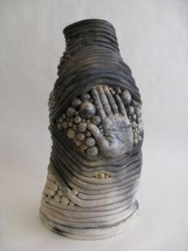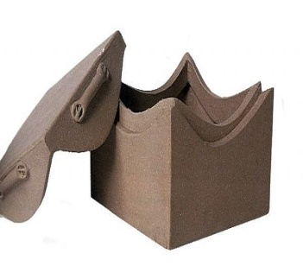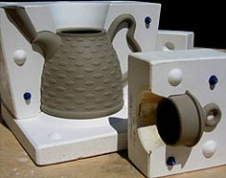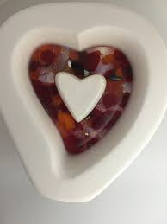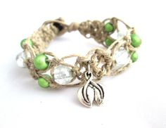
Class Description
The goal of this class is to hone your clay and ceramics skills with advanced hand-building techniques in coil and slab as well as slip casting. You will also be introduced to basic fusing, slumping, soldering and blowing of glass. Following safety procedures will be essential to your success.
Your work in glass may include:  - Copper foil  - Stained glass  - Fused glass  - Lampworking  - Mixed media  - Blown Glass  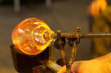  Class Expectations:  Projects – You will be expected to complete all projects to the best of your ability within a given time frame.  Class Participation – You will receive daily participation points. These points are easily maintained by being on time, staying on task and by working respectfully and safely.  Course Folder – You are expected to maintain a folder with all handouts and sketches for the course. It is extremely important for an art student to be organized and to have all process information easily accessible. The folder will remain in the classroom.  Box – All students need a wooden tray to separate works in progress within the shared cubby. | Class Rules:  - Arrive to class on time.  - Be prepared for class.  - Stay on task and complete assignments.  - Workspace must be organized and clean.  - Open toe shoes are not permitted.  - Ask permission to leave the room.  - Respect other student’s ideas.  - Absolutely no food or drink in the studio.  - MP3s, ipods, etc are a privilege. They may be used while working. Ear buds must be removed during demonstrations.  - Smart phones are an excellent tool for the artist if used properly. Texting is not allowed. Phones need to be in the caddy unless permission is obtained. Unauthorized use will result in a referral.  - Work hard and treat others as you would like to be treated.  Studio Fees:  Glaze, Glass and necessary equipment are extremely expensive. Therefore, it is necessary for students to follow procedures for waste and care. If damage to equipment or supplies occurs a fee will be charged.  Checks should be made to :  LFO Art Club include dr. lic. and 2 phone no

